HTML CSS

📘 Definition
# Source: AI Source: Provided by: [Data Path: Persons Table -> ID Column: 1, Name_En Column: Motasem Essam] -> From: [ChatGPT] on [5/6/2026]
CSS (Cascading Style Sheets) is a stylesheet language used to design and style HTML webpages.
While HTML creates the structure/content, CSS controls the:
- 🎨 Colors
- 📏 Sizes
- 🖼️ Layouts
- ✨ Animations
- 📱 Responsive design

🧱 HTML vs CSS
# Source: AI Source: Provided by: [Data Path: Persons Table -> ID Column: 1, Name_En Column: Motasem Essam] -> From: [ChatGPT] on [5/6/2026]
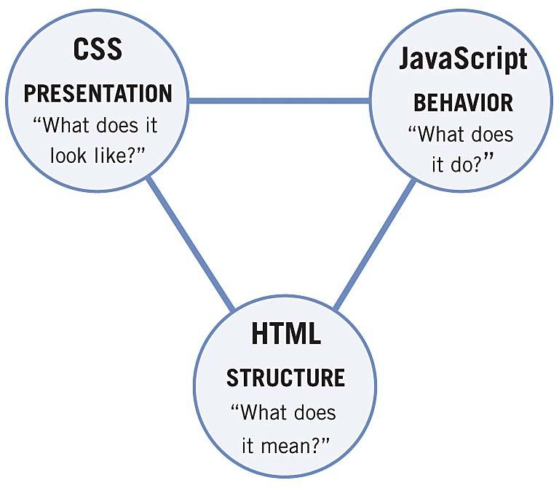
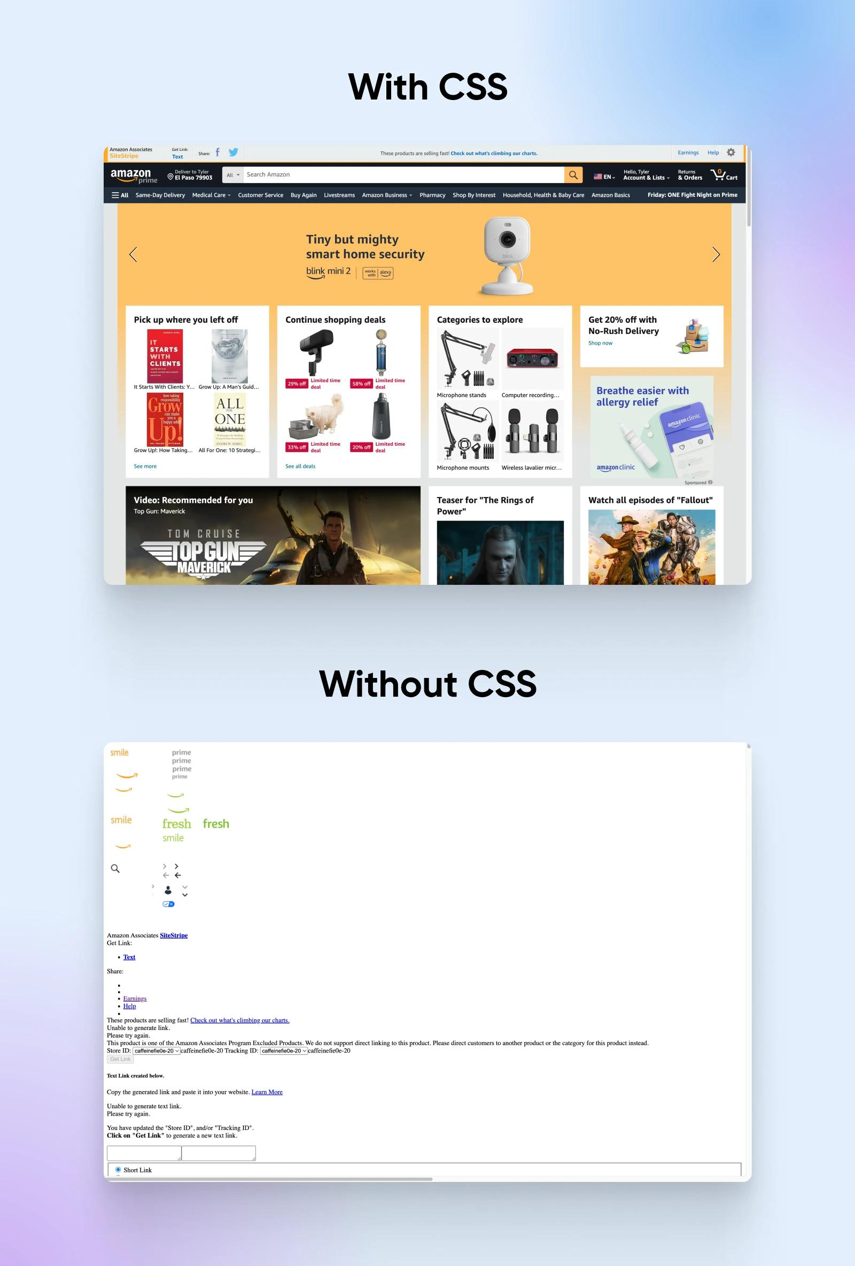
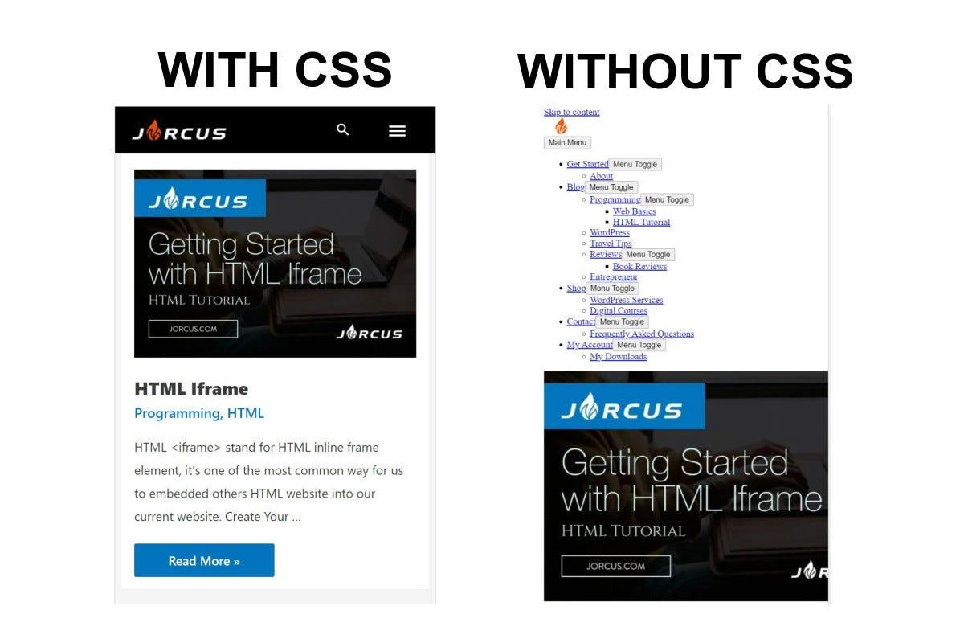
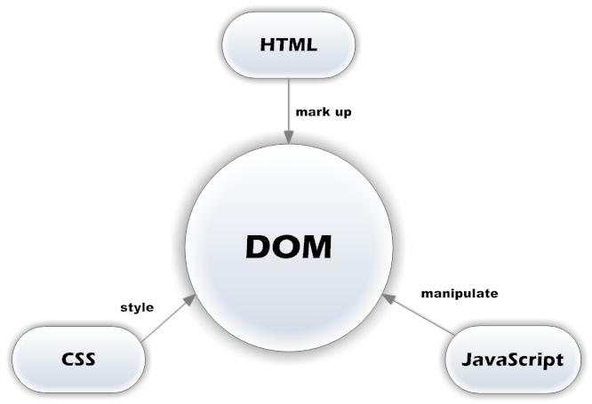
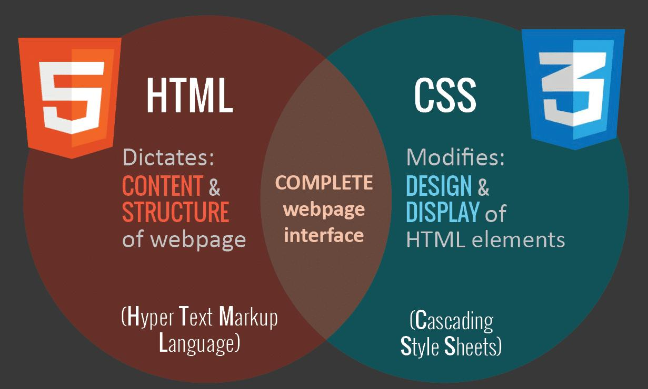
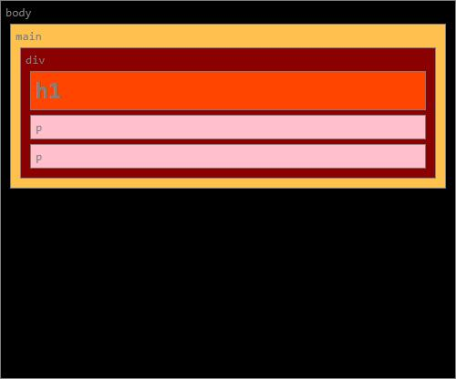
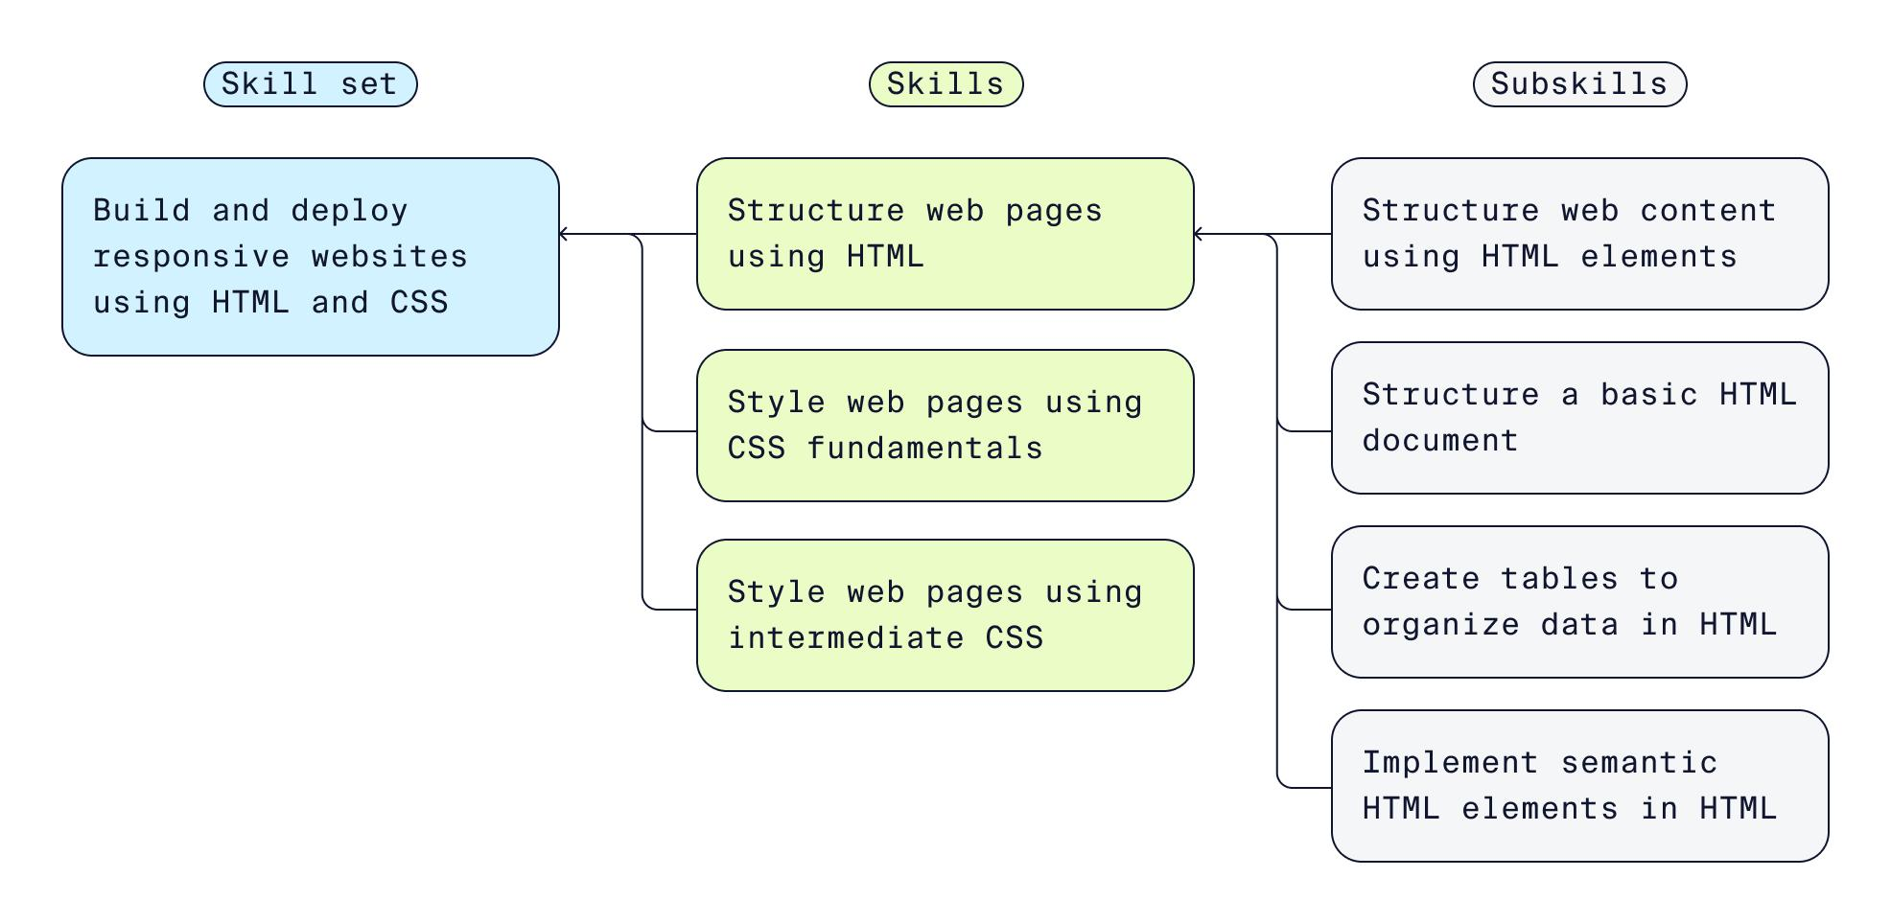
Technology | Purpose
HTML | Structure/content
CSS | Design/style

🧪 Common Uses of CSS (with examples)

🎨 1. Change Colors
# Source: AI Source: Provided by: [Data Path: Persons Table -> ID Column: 1, Name_En Column: Motasem Essam] -> From: [ChatGPT] on [5/6/2026]
📖 Description:
CSS changes text and background colors.
💻 Full Example:
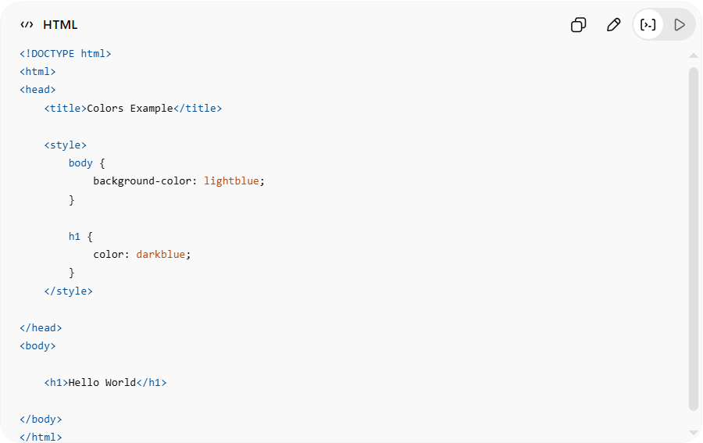
<!DOCTYPE html>
<html>
<head>
<title>Colors Example</title>

<style>
body {
background-color: lightblue;
}

h1 {
color: darkblue;
}
</style>

</head>
<body>

<h1>Hello World</h1>

</body>
</html>
👉 Changes page and text colors

📏 2. Change Size and Spacing
# Source: AI Source: Provided by: [Data Path: Persons Table -> ID Column: 1, Name_En Column: Motasem Essam] -> From: [ChatGPT] on [5/6/2026]
📖 Description:
CSS controls width, height, margin, padding, and font sizes.
💻 Full Example:
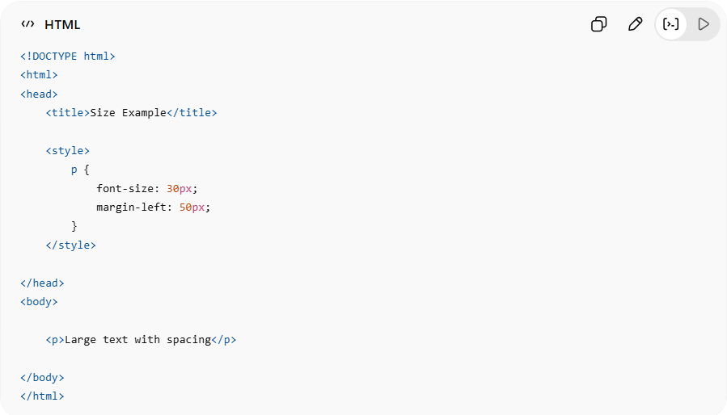
<!DOCTYPE html>
<html>
<head>
<title>Size Example</title>

<style>
p {
font-size: 30px;
margin-left: 50px;
}
</style>

</head>
<body>

<p>Large text with spacing</p>

</body>
</html>
👉 Controls element sizing and spacing

🖼️ 3. Add Borders and Backgrounds
# Source: AI Source: Provided by: [Data Path: Persons Table -> ID Column: 1, Name_En Column: Motasem Essam] -> From: [ChatGPT] on [5/6/2026]
📖 Description:
CSS styles element appearance.
💻 Full Example:
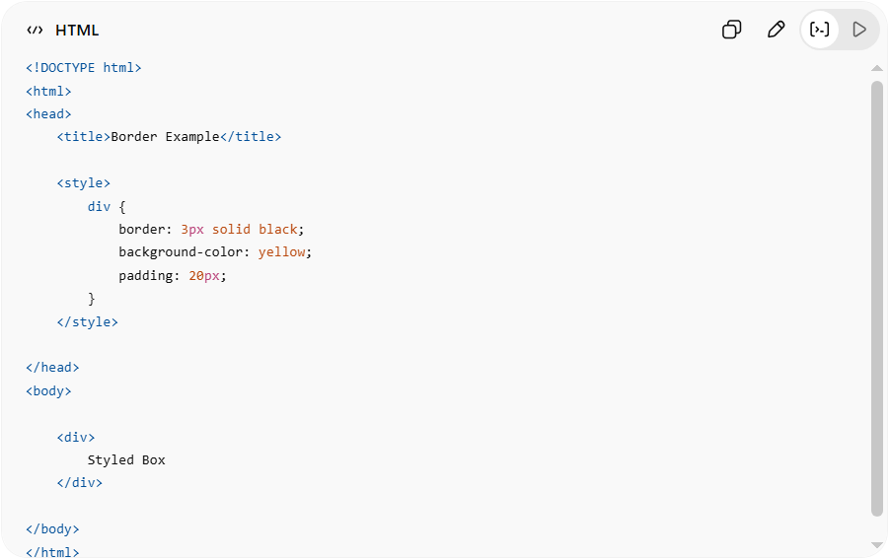
<!DOCTYPE html>
<html>
<head>
<title>Border Example</title>

<style>
div {
border: 3px solid black;
background-color: yellow;
padding: 20px;
}
</style>

</head>
<body>

<div>
Styled Box
</div>

</body>
</html>
👉 Adds border and background

📱 4. Create Responsive Design
# Source: AI Source: Provided by: [Data Path: Persons Table -> ID Column: 1, Name_En Column: Motasem Essam] -> From: [ChatGPT] on [5/6/2026]
📖 Description:
CSS adapts layout to different screen sizes.
💻 Full Example:
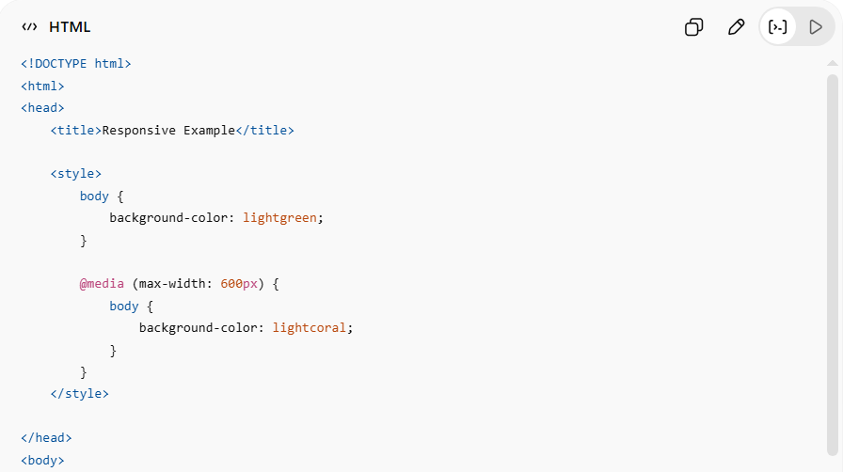
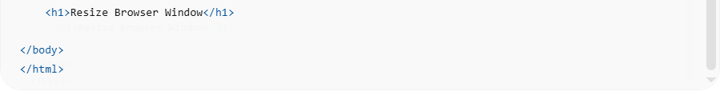
<!DOCTYPE html>
<html>
<head>
<title>Responsive Example</title>

<style>
body {
background-color: lightgreen;
}

@media (max-width: 600px) {
body {
background-color: lightcoral;
}
}
</style>

</head>
<body>

<h1>Resize Browser Window</h1>

</body>
</html>
👉 Design changes on small screens

✨ 5. Add Hover Effects
# Source: AI Source: Provided by: [Data Path: Persons Table -> ID Column: 1, Name_En Column: Motasem Essam] -> From: [ChatGPT] on [5/6/2026]
📖 Description:
CSS changes style when user interacts.
💻 Full Example:
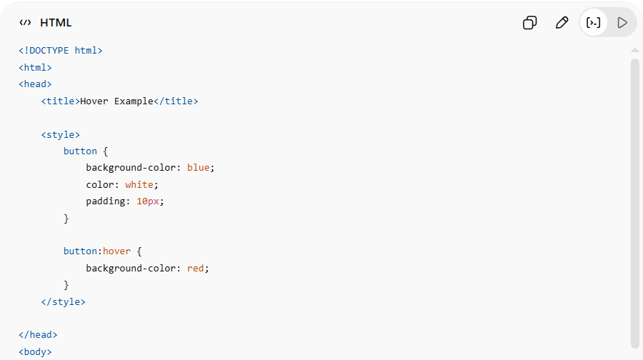
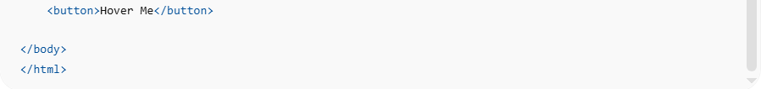
<!DOCTYPE html>
<html>
<head>
<title>Hover Example</title>

<style>
button {
background-color: blue;
color: white;
padding: 10px;
}

button:hover {
background-color: red;
}
</style>

</head>
<body>

<button>Hover Me</button>

</body>
</html>
👉 Button changes color on hover

🎞️ 6. Create Animations
# Source: AI Source: Provided by: [Data Path: Persons Table -> ID Column: 1, Name_En Column: Motasem Essam] -> From: [ChatGPT] on [5/6/2026]
📖 Description:
CSS can animate movement and transitions.
💻 Full Example:
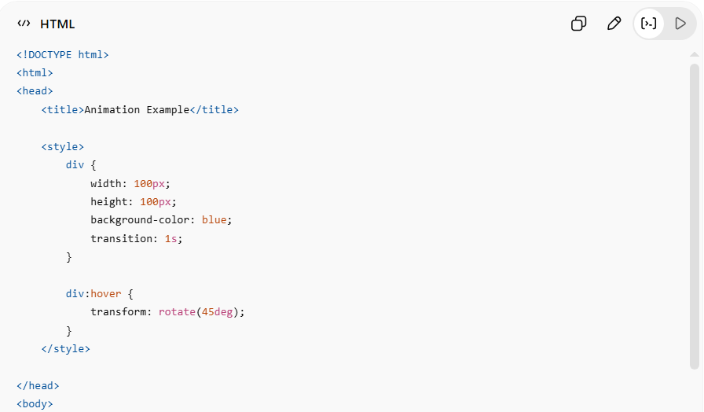
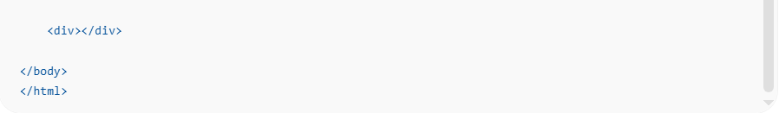
<!DOCTYPE html>
<html>
<head>
<title>Animation Example</title>

<style>
div {
width: 100px;
height: 100px;
background-color: blue;
transition: 1s;
}

div:hover {
transform: rotate(45deg);
}
</style>

</head>
<body>

<div></div>

</body>
</html>
👉 Element rotates on hover

🎨 Ways to Add CSS

🟢 Inline CSS
# Source: AI Source: Provided by: [Data Path: Persons Table -> ID Column: 1, Name_En Column: Motasem Essam] -> From: [ChatGPT] on [5/6/2026]
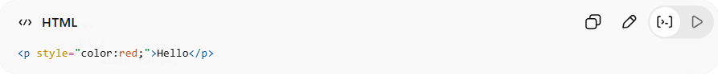
<p style="color:red;">Hello</p>
👉 CSS inside HTML element

🟡 Internal CSS
# Source: AI Source: Provided by: [Data Path: Persons Table -> ID Column: 1, Name_En Column: Motasem Essam] -> From: [ChatGPT] on [5/6/2026]
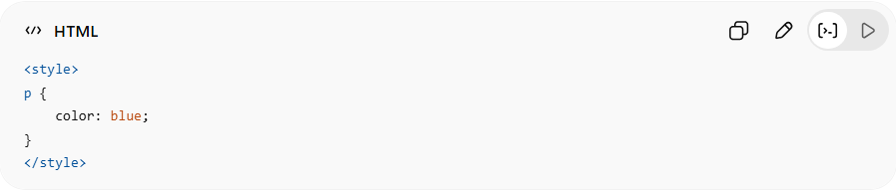
<style>
p {
color: blue;
}
</style>
👉 CSS inside <style>

🔵 External CSS (Best Practice)
# Source: AI Source: Provided by: [Data Path: Persons Table -> ID Column: 1, Name_En Column: Motasem Essam] -> From: [ChatGPT] on [5/6/2026]
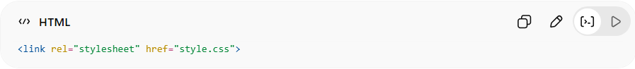
<link rel="stylesheet" href="style.css">
👉 Separate CSS file

⚙️ Key Features of CSS
# Source: AI Source: Provided by: [Data Path: Persons Table -> ID Column: 1, Name_En Column: Motasem Essam] -> From: [ChatGPT] on [5/6/2026]
- 🎨 Styles webpages
- 📱 Creates responsive layouts
- ✨ Adds animations/effects
- 🧩 Separates design from HTML
- 🌐 Improves user experience

🚀 In short:
# Source: AI Source: Provided by: [Data Path: Persons Table -> ID Column: 1, Name_En Column: Motasem Essam] -> From: [ChatGPT] on [5/6/2026]
CSS = the language used to design and style HTML webpages.

